Revision of the IC Design Textbook (V2.0)
- Chapter 5, Page 152-153
In this block of code there are two errors: 1) the initial block is missing as shown in the figure; 2) cout should be modified into c_out as shown in the second block.
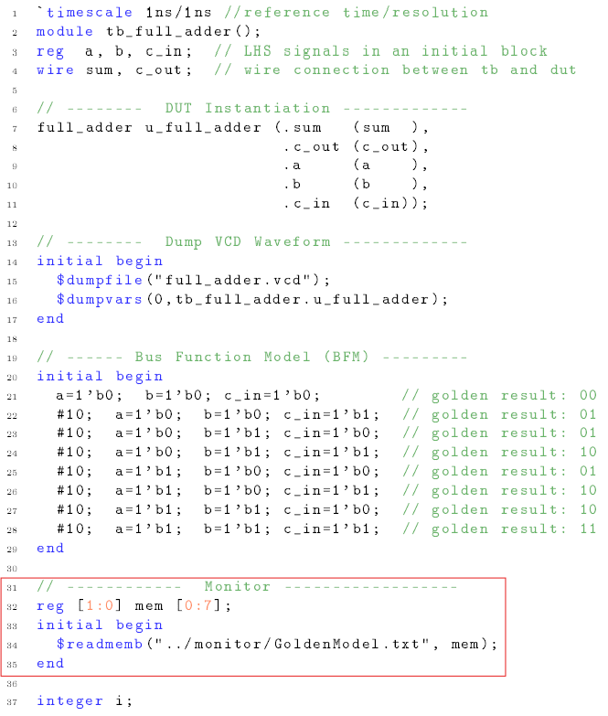
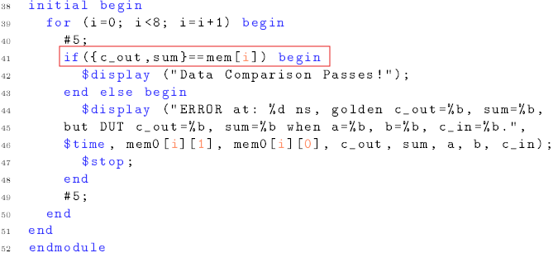
- Chapter 10, Page 358
The figure 10.10 should be modified as below:
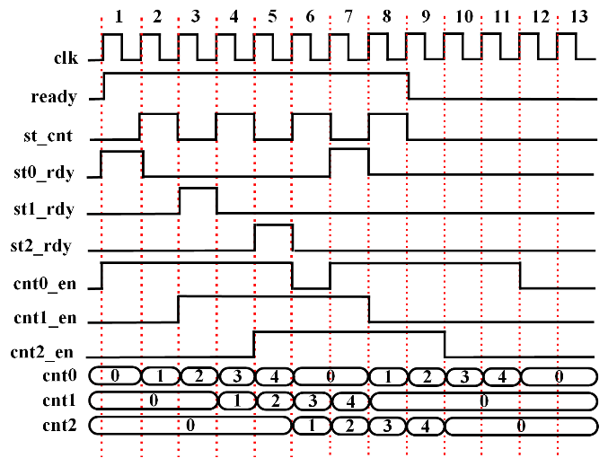

- Chapter 9, Page 310
\paragraph{B. Timing Diagram}
Figure~\ref{ch9:reg-file-we-tim} presents two timing diagrams illustrating write operations on a register file. In the first example, depicted in Figure~\ref{subfig:reg-file-wef-tim}, write operations are enabled during clock cycles 1-4, with corresponding write addresses of 2'h0-2'h3. Four data words, specifically 32'h01234567, 32'h89abcdef, 32'h10111212, and 32'h14151617, are written into the registers. Each write operation activates all four bytes of the write data bus (``we=4'hf''). In clock cycles 5-8, read addresses of 2'h0-2'h3 are generated to verify the successful data write. It's important to note that there is a one-clock cycle delay between the read addresses and the availability of the read data, resulting in the data being read out during clock cycles 6-9.
The second example, depicted in Figure~\ref{subfig:reg-file-we3-tim}, demonstrates write operations performed in words and half-words to showcase the difference. In clock cycles 1-2, the write enable signal and write addresses are activated. The write data, 32'h01234567 and 32'h89abcdef, are written into the registers with the corresponding addresses 2'h0 and 2'h1, respectively, as the write enable signal enables all the write data bytes (``we=4'hf''). This can be observed in the subsequent data read addresses in clock cycles 3-4 and the corresponding data read out on the read data bus in clock cycles 4-5.
In the following sequence, during clock cycles 5-6, another round of data writing takes place. However, this time, only the lower two bytes are enabled with the write enable signal set to hexadecimal 4'h3. Despite having write data values of 32'h10111213 and 32'h14151617, only the lower two bytes, 16'h1213 and 16'h1617, are actually written into the register arrays. The higher two bytes, 16'h1011 and 16'1415, are disregarded by the register operations. Subsequently, as illustrated in the ensuing read operations spanning clock cycles 7-8, the corresponding data is retrieved from the memory by transmitting addresses 2'h0 and 2'h1 once again. During clock cycles 8-9, the data retrieved from the register arrays are 32'h01231213 and 32'h89ab1617, with the lower two bytes updated, while the higher two bytes remain unchanged, preserving the data previously stored in the registers.

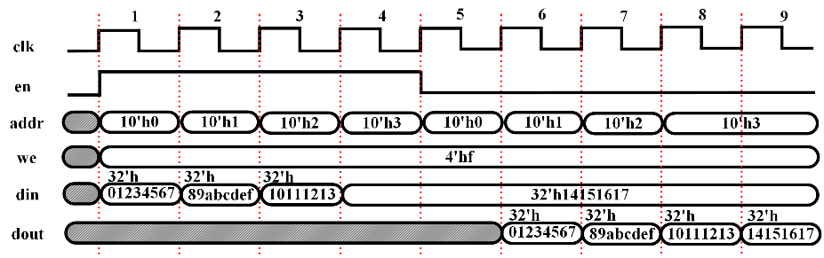
- Timing Diagram of Register File Access with ``we=4'hf''
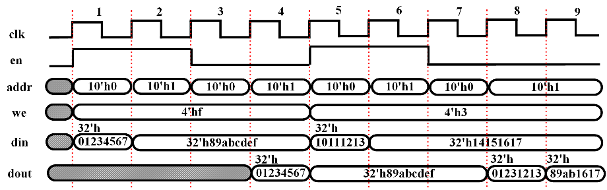
- Timing Diagram of Register File Access with ``we=4'hf'' and ``we=4'h3''
Figure 9.5 Timing Diagram of Register File Access Utilizing Write Enable Controlling

- Chapter 11, page 405 Fig. 11.22 should be modified as below
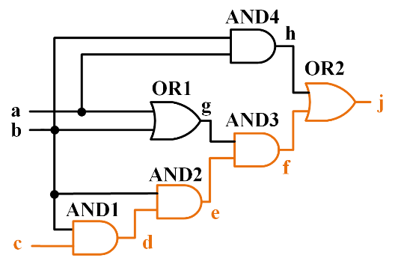
- Chapter 11, page 404, Problem 11.3. Change the code as below: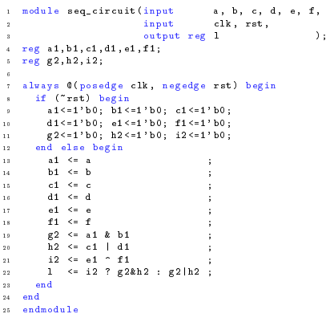

- Chapter 12, Page 440 Fig. 12.19 and Page 441 Fig. 12.20 should be modified as below
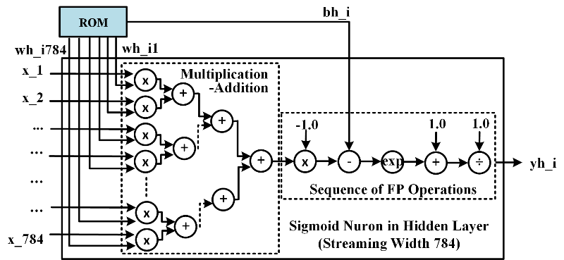
Figure 12.19 Streaming design structure of hidden-layer neuron
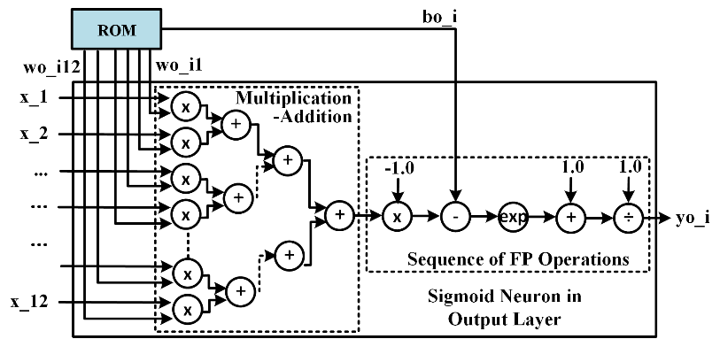
Figure 12.20 Streaming design structure of output-layer neuron

